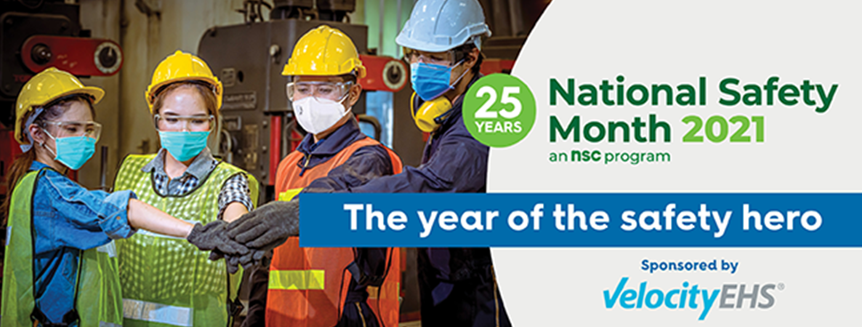
National Safety Month 2021 – Social Media Kit
Social Media Kit Instructions:
- Download images in the boxes below.
- You may use these post suggestions, or simply use them as inspiration to create your own posts.
- Include the #NSM hashtag so we’re all part of the same social conversation.
- IMPORTANT: Be sure to type out and select ‘@National Safety Council’ in Facebook and LinkedIn posts for proper tagging. You can also share messages from the National Safety Council social media pages. We’ll be posting about National Safety Month during June across these channels:
  - Facebook
  - Twitter
  - LinkedIn
  - Instagram
Questions? Contact Al Lagattolla at Al.Lagattolla@nsc.org
Image | Facebook/LinkedIn Post |  | Twitter Post
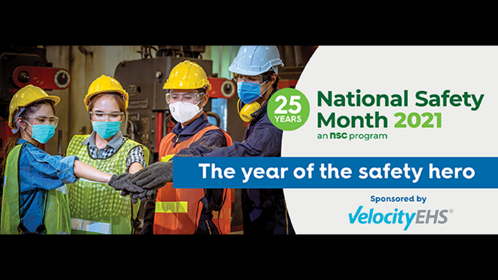 | Who is your #SafetyHero? June is National Safety Month. Join the @National Safety Council and recognize a safety professional – or anyone who inspires you to be safe: http://bit.ly/nscnsm2021  #NSM  [Type out the green text to tag the NSC page] |  | Who is your #SafetyHero? June is National Safety Month. Join @NSCSafety and recognize a safety professional – or anyone who inspires you to be safe: http://bit.ly/nscnsm2021  #NSM
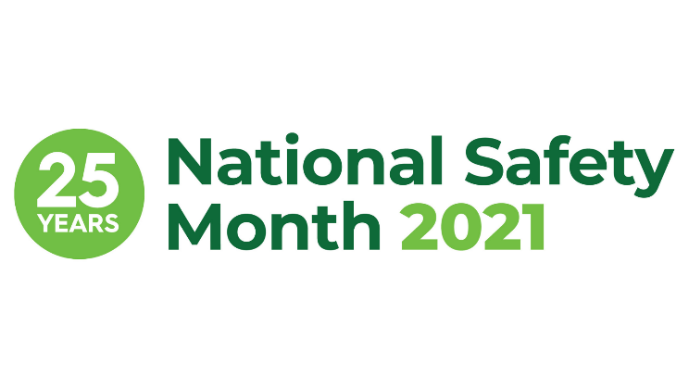 | Safety is more critical now than ever. Get free @National Safety Council resources to improve safety this National Safety Month: http://bit.ly/nscnsm2021 #NSM  [Type out the green text to tag the NSC page] |  | Safety is more critical now than ever. Get free @NSCSafety resources to improve safety this National Safety Month: http://bit.ly/nscnsm2021 #NSM
 | We’re excited to join the @National Safety Council in celebrating the 25th annual National Safety Month in June! Sign up for free materials to keep your co-workers safe: http://bit.ly/nscnsm2021 #NSM  [Type out the green text to tag the NSC page] |  | We’re excited to join @NSCSafety in celebrating the 25th annual National Safety Month in June! Sign up for free materials to keep your co-workers safe: http://bit.ly/nscnsm2021 #NSM
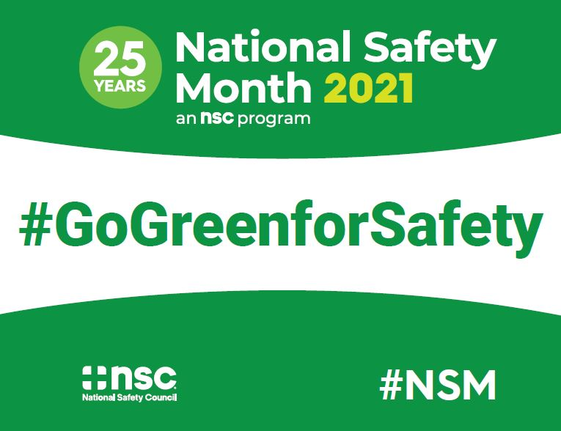 | We’re proud to #GoGreenforSafety with the @National Safety Council during the 25th anniversary of National Safety Month. Wear your safety green to show your commitment to safety: http://bit.ly/nscnsm2021 #NSM  [Type out the green text to tag the NSC page] | We’re proud to #GoGreenforSafety with @NSCSafety during the 25th anniversary of National Safety Month. Get free materials to show your commitment to safety: http://bit.ly/nscnsm2021 #NSM
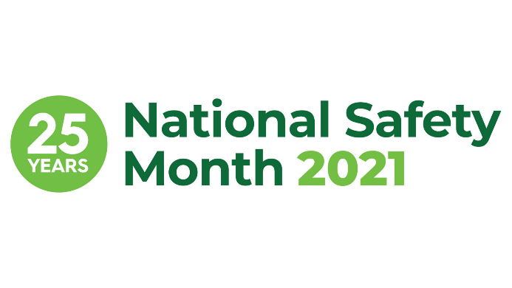 | The @National Safety Council offers free workplace safety resources during National Safety Month, and NSC members get even more! Not a member? Join today at https://bit.ly/howtojoinnsc  [Type out the green text to tag the NSC page] | .@NSCSafety offers free workplace safety resources during National Safety Month, and NSC members get even more! Not a member? Join today at https://bit.ly/howtojoinnsc
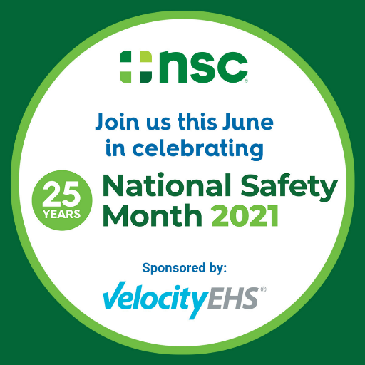 | Every worker deserves to make it home safe. [Insert organization activities during National Safety Month]. Get @National Safety Council tips and tools to help protect your workforce during #NSM: http://bit.ly/nscnsm2021  [Type out the green text to tag the NSC page] |  | Every worker deserves to make it home safe. [Insert organization activities during National Safety Month]. Get @NSCSafety tips and tools to help protect your workforce during #NSM: http://bit.ly/nscnsm2021
Week 1: Prevent Incidents Before They Start
GIF To Share
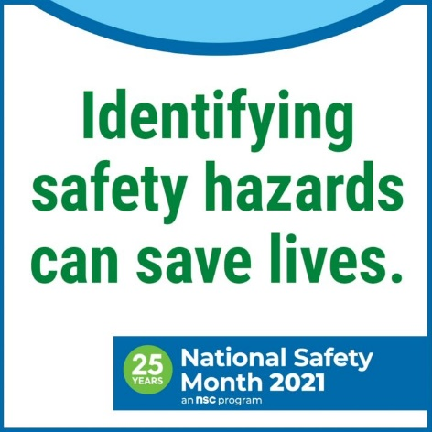  Email socialmedia@nsc.org if you would like the GIF. Or you can copy and paste this link in your social media post: https://www.youtube.com/watch?v=nvJaEN_PgA0 | Prevent incidents before they start. June is National Safety Month. The @National Safety Council can help you identify risks and take proactive safety measures to create a safe workplace: http://bit.ly/nscnsm2021 #NSM  [Type out the green text to tag the NSC page] |  | Prevent incidents before they start. June is National Safety Month. @NSCSafety can help you identify risks and take proactive safety measures to create a safe workplace: http://bit.ly/nscnsm2021 #NSM
Week 2: Address Ongoing COVID-19 Safety Concerns
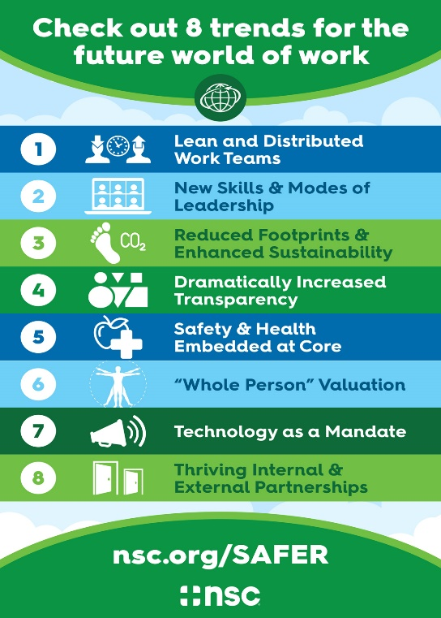 | Are you ready for the future world of work? Check out these trends so you can be best prepared. June is National Safety Month. Download free @National Safety Council resources: http://bit.ly/nscnsm2021 #NSM  [Type out the green text to tag the NSC page] | Are you ready for the future world of work? June is National Safety Month. Download free @NSCSafety resources to help: http://bit.ly/nscnsm2021 #NSM
Week 3: It’s Vital to Feel Safe on the Job
GIF To Share
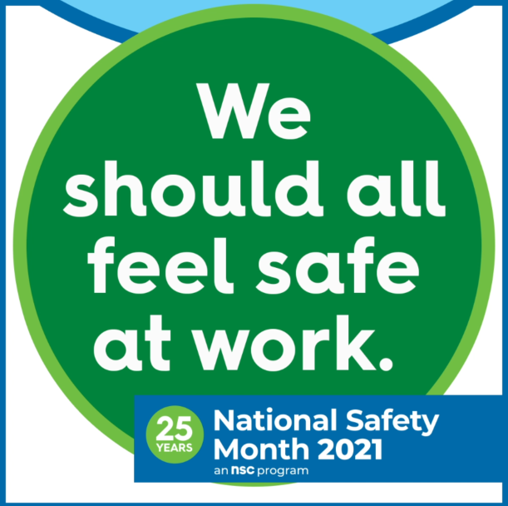  Email socialmedia@nsc.org if you would like the GIF. Or you can copy and paste this link in your social media post: https://youtu.be/1vt8LU2TOAA | It’s vital to feel safe on the job. June is National Safety Month. Being able to be one’s self at work without fear of retaliation is necessary for an inclusive safety culture. Get more tools from @National Safety Council: http://bit.ly/nscnsm2021 #NSM  [Type out the green text to tag the NSC page] | It’s vital to feel safe on the job. June is National Safety Month. Being able to be one’s self at work without fear of retaliation is necessary for an inclusive safety culture. Get more tools from @NSCSafety: http://bit.ly/nscnsm2021 #NSM
Week 4: Advance Your Safety Journey
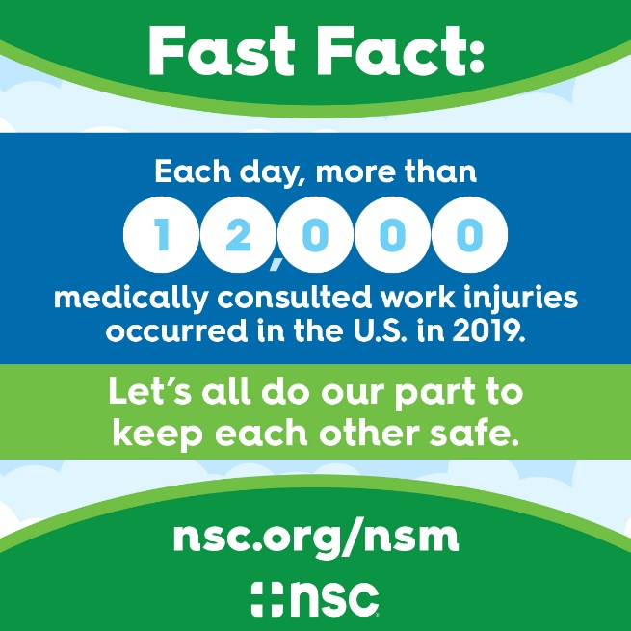 | Work-related injuries totaled more than 4 million in 2019. Advance your safety journey to bring these numbers down. June is National Safety Month, and the @National Safety Council. can help provide guidance for your path forward: http://bit.ly/nscnsm2021  #NSM  [Type out the green text to tag the NSC page] | Advance your safety journey to prevent workplace injuries. June is National Safety Month, and @NSCSafety can help provide guidance for your path forward: http://bit.ly/nscnsm2021  #NSM

Facebook Frame Instructions:
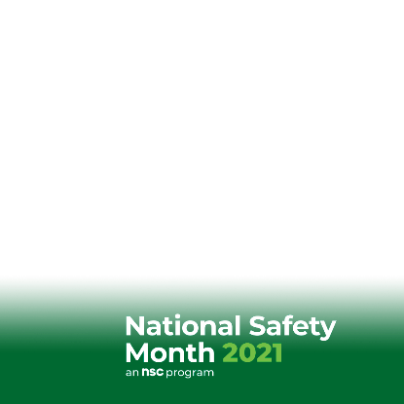
Option 1: Change it on your Facebook page
Step 1: Go to your own Facebook Profile. You can find your profile page by clicking on your icon in the top LEFT corner of your news feed.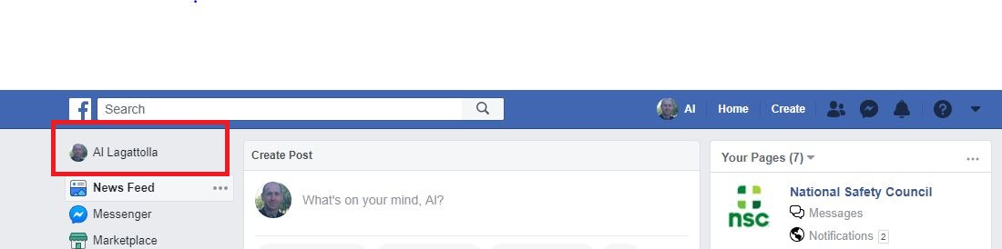

Step 2: Hover over your profile photo and click the camera icon.
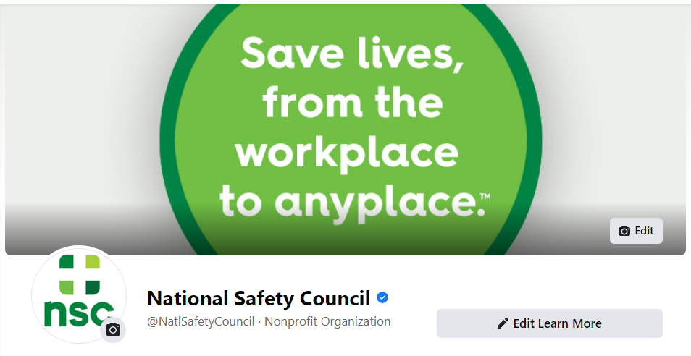

Step 3: Once you click on the camera icon, a box should appear with photos. Look at the top of the auto-populate box and select “Add Frame.”
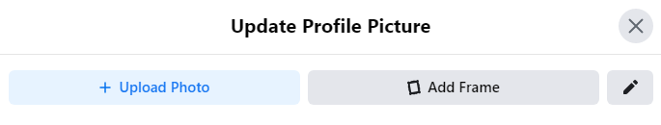

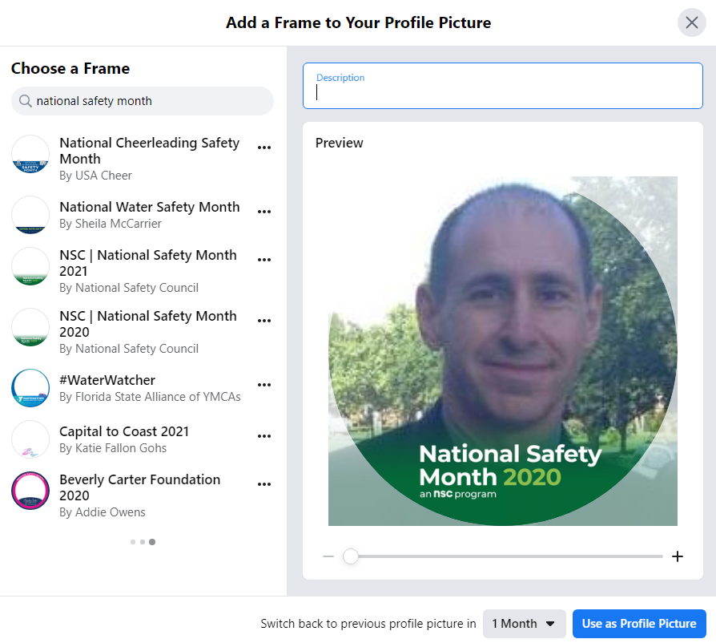
Step 4: Type “National Safety Month” in the search field in the top left corner, and the frame that says “NSC | National Safety Month 2021” should be among the options. Select that frame for the list and crop your profile filter however you see fit. You can decide how long you want to use the frame and then hit “Use as Profile Picture.”

Option 2: Straight from the NSC Post
NSC will publish a post on June 1, 2021, highlighting the filter and announcing the start of National Safety Month. Once that post is up, you’ll be able to select the National Safety Month 2021 frame.
